
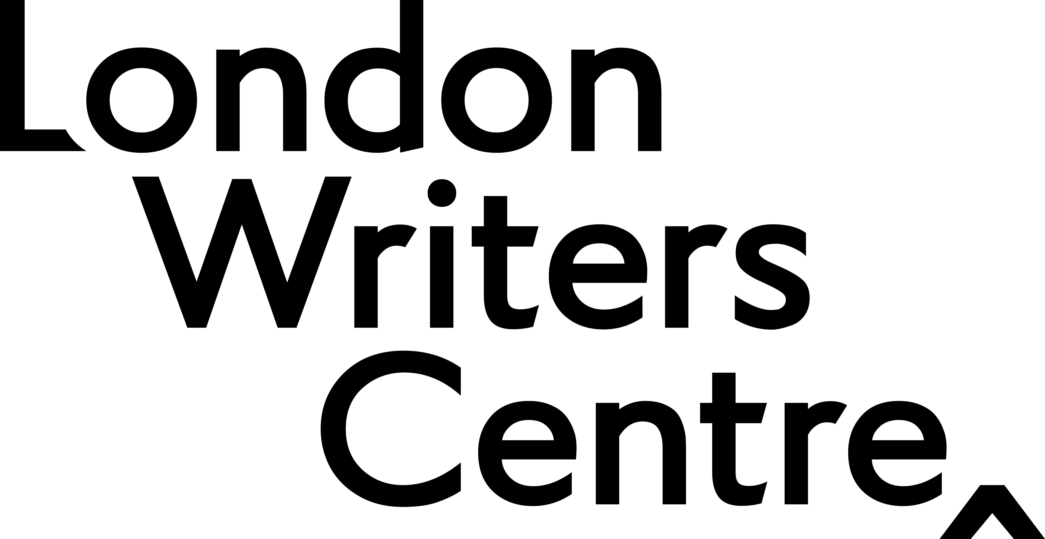

Terms and Conditions
We are delighted to announce the There Is Only Narrative Competition managed by London Writers Centre in partnership with the Eve White Literary Agency.

Please read these terms and conditions before submitting your work.

Competition Terms and Conditions

- The There Is Only Narrative Competition is open to writers aged 18+ and full-time resident in the UK, who are emerging writers underrepresented in UK publishing, we define this as:
  - By underrepresented we mean writers from one or more the following communities:
    - Black, Asian, Global Majority
    - Disabled
    - LGBTQIA+
    - Low Income*
    - Working Class Upbringing
*We define low-income as earning on or below the Living Wage and/or in receipt of benefits such as Universal Credit.
  - By emerging we mean:
    - Unagented
    - Does not have a publishing contract for a full-length work at the time of entering (please let London Writers Centre know if you sign a publishing deal for a full-length work after you have entered the Competition, as this would render you ineligible).
    - Has not previously published in print a full-length work. We define a full-length work as:
      - A complete work of fiction or non-fiction over 50,000 words;
      - Ten or more short stories either in a collection or published individually;
      - A professionally produced theatre script or screenplay, or radio play;
      - Twenty or more poems either in a collection or published individually.

- For the purposes of the competition, self-published authors of any of the definitions above are welcome to enter a submission that has not already been published or self-published.
- For the purposes of the competition, authors of academic and/or educational works are welcome to enter a submission that has not already been published or self-published.

- For the purposes of the competition, please refer to the There Is Only Narrative Getting Started with Writing a Non-Fiction Proposal Parts 1 and 2. The documents are available upon request by completing this form: Eve White Literary Agency - There Is Only Narrative Survey – Fill in form

- Applications will be accepted online through our Submittable page: https://spreadtheword.submittable.com/submit.

- Entries must be a mini-proposal for a new general trade non-fiction book. The book does not need to be completed.

- The submission will be a mini non-fiction proposal at a maximum of 3,700 words in total and consisting of:

- Title and Subtitle (Subtitle is optional)
- Pitch - 25-40 words
- Summary of Project - 200-300 words
- Author Biography - 150-300 words
- Extract from proposed project - 3,000 words maximum

- The writing sample when submitted online must be submitted as a text document [.doc, .docx, .pdf], typed in black, 12-point font, double spaced and paginated and submitted online via Submittable.

- Only one submission will be considered per entrant. Multiple entries by the same entrant will result in only the first entry being considered for the Competition and any additional entries disqualified.
- Entries must be the original, previously unpublished work of the entrant. Pieces of writing that have already secured a publishing deal but have not yet been published are ineligible.

- All work submitted for consideration must be the entrant's own original writing and should not have been published online, in a physical format or have been broadcast on or before December 2026. Work found to published online, in a physical format or have been broadcast will be disqualified. This includes pieces that are self-published on a blog or in a self-published book.

- The use of Generative AI is not allowed in the composing of submissions. Any entries found to have used Generative AI will be disqualified.

- Entries must be the individual and original work of a sole author.
- Entries must be in English.

- Due to the volume of entries the Competition receives, London Writers Centre is unable to provide feedback for any entries.

- All entries will be judged anonymously. To that effect, please ensure that your entry does not contain your name on any of the pages. Any entries with names or identifying information will be disqualified.
- If any of the reading and judging panels recognise an entry, they can participate in a discussion about the piece but will recuse themselves from casting a vote.
- Entries can be submitted from Wednesday 22 April 2026 at midday. The closing date for entries is 5pm on Tuesday 23 June 2026.
- Entries may be simultaneously submitted elsewhere, however, should an entry win another prize or set to be published elsewhere, it must be withdrawn from this Competition. It is the writer’s responsibility to inform London Writers Centre of this.
- The Prizes on offer will see 4-6 entrants named as winners. The winners will receive:
  - A 60-minute group meeting with the author Damien Le Bas,
  - A 60-minute group meeting with a staff member from London Writers Centre.
  - A 121 meeting with a literary agent from the Eve White Literary Agency.

- Reasonable adjustments will be made for disabled writers placed in the Competition.

- There are no cash alternative to the prizes.
- All entrants will know the outcome of their submission by Wednesday 7 October 2026.

- The winners will agree to any reasonable request by London Writers Centre to fulfil press and marketing obligations relating to the competition and their own entry.
- Copyright will remain with the author.

- Employees or Trustees of London Writers Centre and/or their close family members, employees of the Eve White Literary Agency and/or their close family members, and those contracted to work on the There Is Only Narrative project and/or their close family members are not permitted to enter.

- The judges’ decision is final and no correspondence or discussion about the judging process will be entered into.

- These terms and conditions are the Competition Rules. Submission of an entry will be taken to mean acceptance of these terms and conditions. Entries that fail to comply with these rules may be disqualified.
- There may be extenuating circumstances that render the dates and timelines in this document flexible. London Writers Centre reserve the right to alter these dates should it be necessary for any reason.

If you have any questions about entering the There Is Only Narrative Competition please contact:

Bobby Nayyar at London Writers Centre at: bobby@londonwriterscentre.org.uk

March 2026

